# Lab 3 Report

## Team Information

**Lab number:** 3

**Date:** 3/24/2016

**Team Members:** Brett Bushnell, Ryan Trumpinski, Sydney Clark, Matt Dzurick

**Team Number/Name:** WeDidTheThing/217 Team Member Responsibilities

**Software Design:** Ryan Trumpinski

**Hardware Design:** Brett Bushnell

**Quality Assurance:** Sydney Clark

**Systems Integrator:** Matt Dzurick

# Hardware

# Tests

## Part 1

|  |  |  |  |
| --- | --- | --- | --- |
| Test Name | Tool | Description | Outcome |
| Potentiometer Test | Digital Multi-meter | Test the potentiometer on the development board by verifying that is changes when spun | The potentiometer voltage did change when spun  See Image 1-1 |
| H-Bridge & Motors Test | Function Generator, DC Power Supply | Check that the motor speed increases as the duty cycle for the function generator increases (and decreases and the duty cycle from function generator decreases). | The motor speed did increase as the duty cycle increased for each motor. The H Bridge worked as expected.  See Image 1-2  See Image 1-3  See Image 1-4 |
| Output Compare Module Test | Oscilloscope | Test output of modules and verify they match up with duty cycle requirements | The output of the modules did change and matched up with duty cycle requirements  See Image 1-5 (measures one of the motors)  See Image 1-6 |
| speedTest() | Oscilloscope | Function that cycles each output compare module through a variety of duty cycles to test control of the speed of the motors; test ability to spin motors forwards and backwards | The wheels spun at different speeds and worked correctly.  See Image 1-7  (demonstrating one wheel spinning faster than the other) |

## Part 2

|  |  |  |  |
| --- | --- | --- | --- |
| Test Name | Tool | Description | Outcome |
| Connectivity Test | Digital Multi-meter | Test all hardware connections | All hardware connections passed the connectivity test.  See Image 2-1 |
| State Switch Test |  | Test that the switch properly moves through forward, idle, backward, idle states correctly | Switch functioned as expected. |

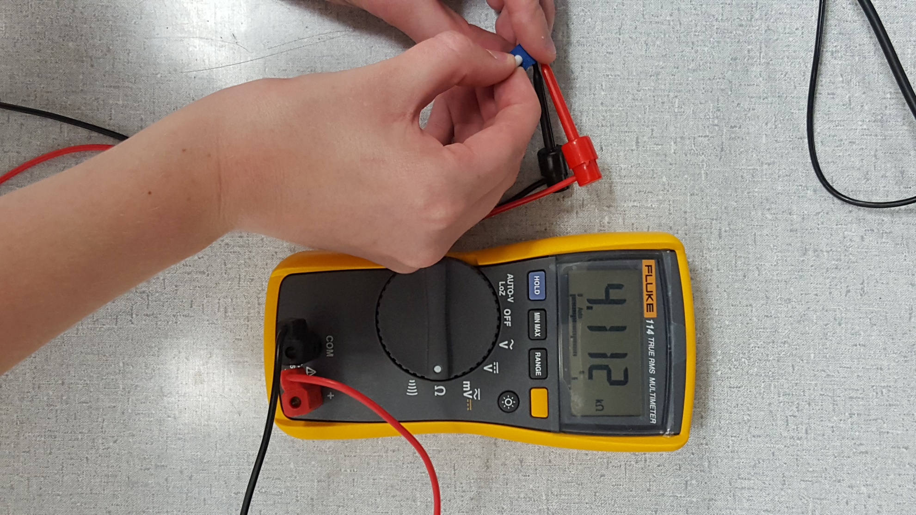

Image 1-1

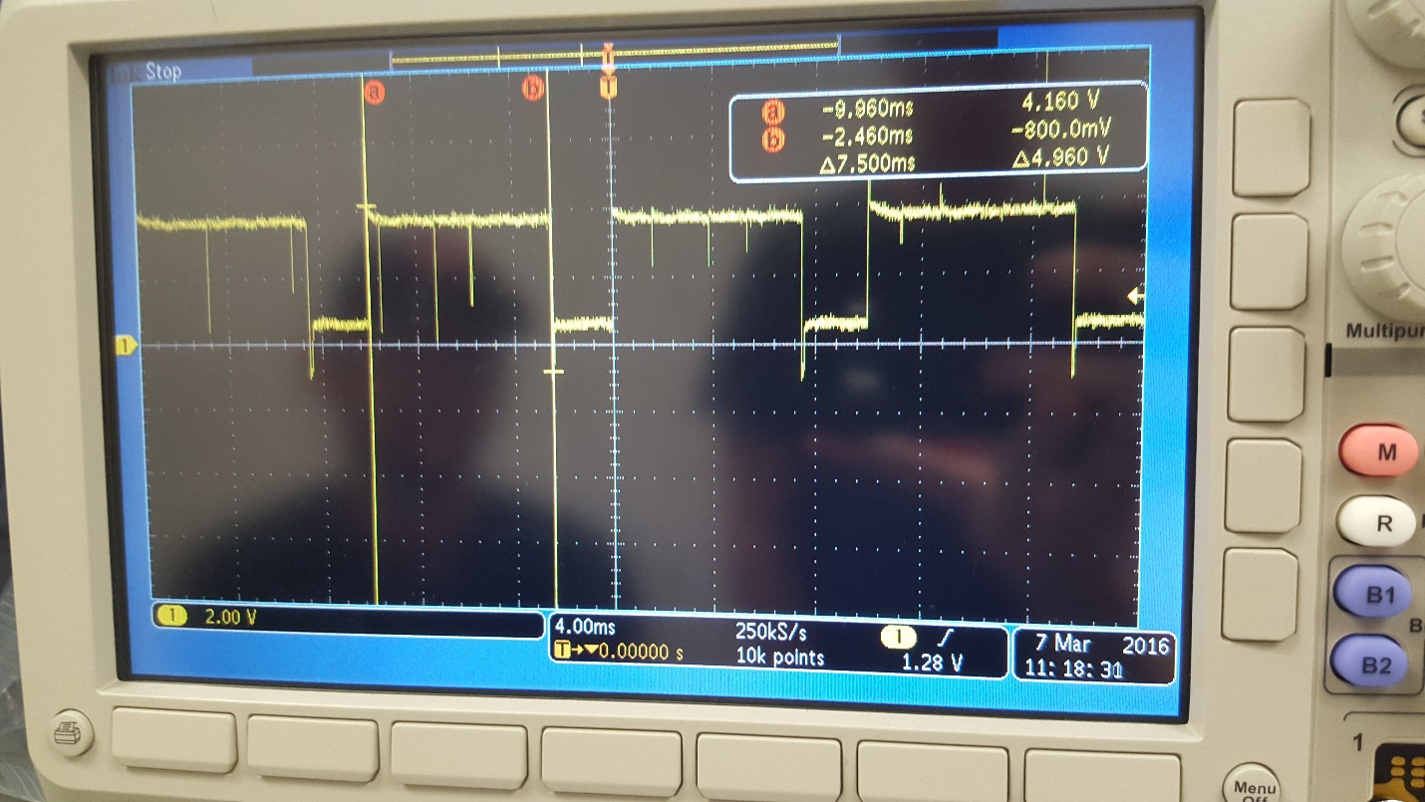

Image 1-2

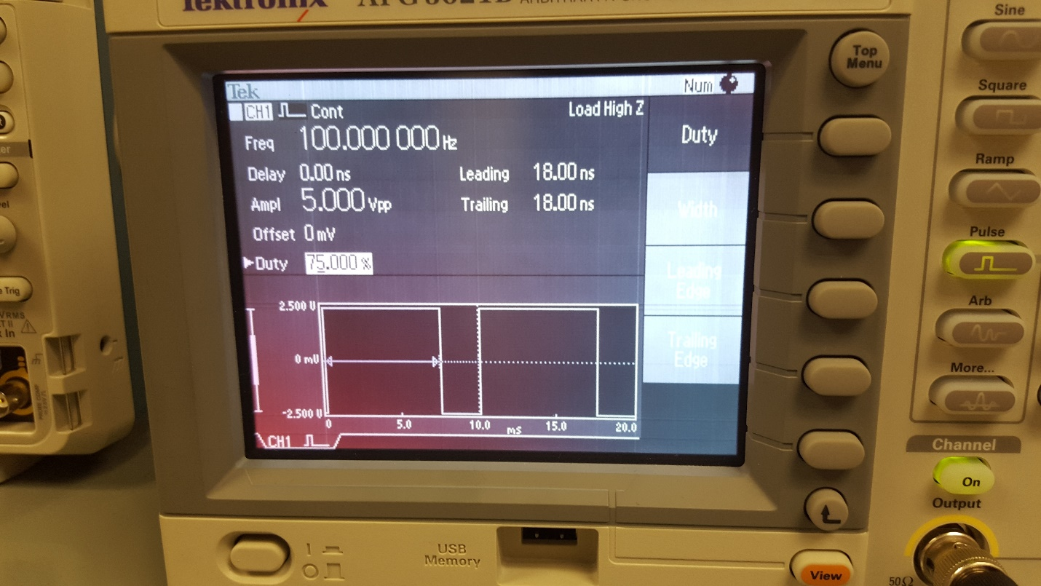

Image 1-3

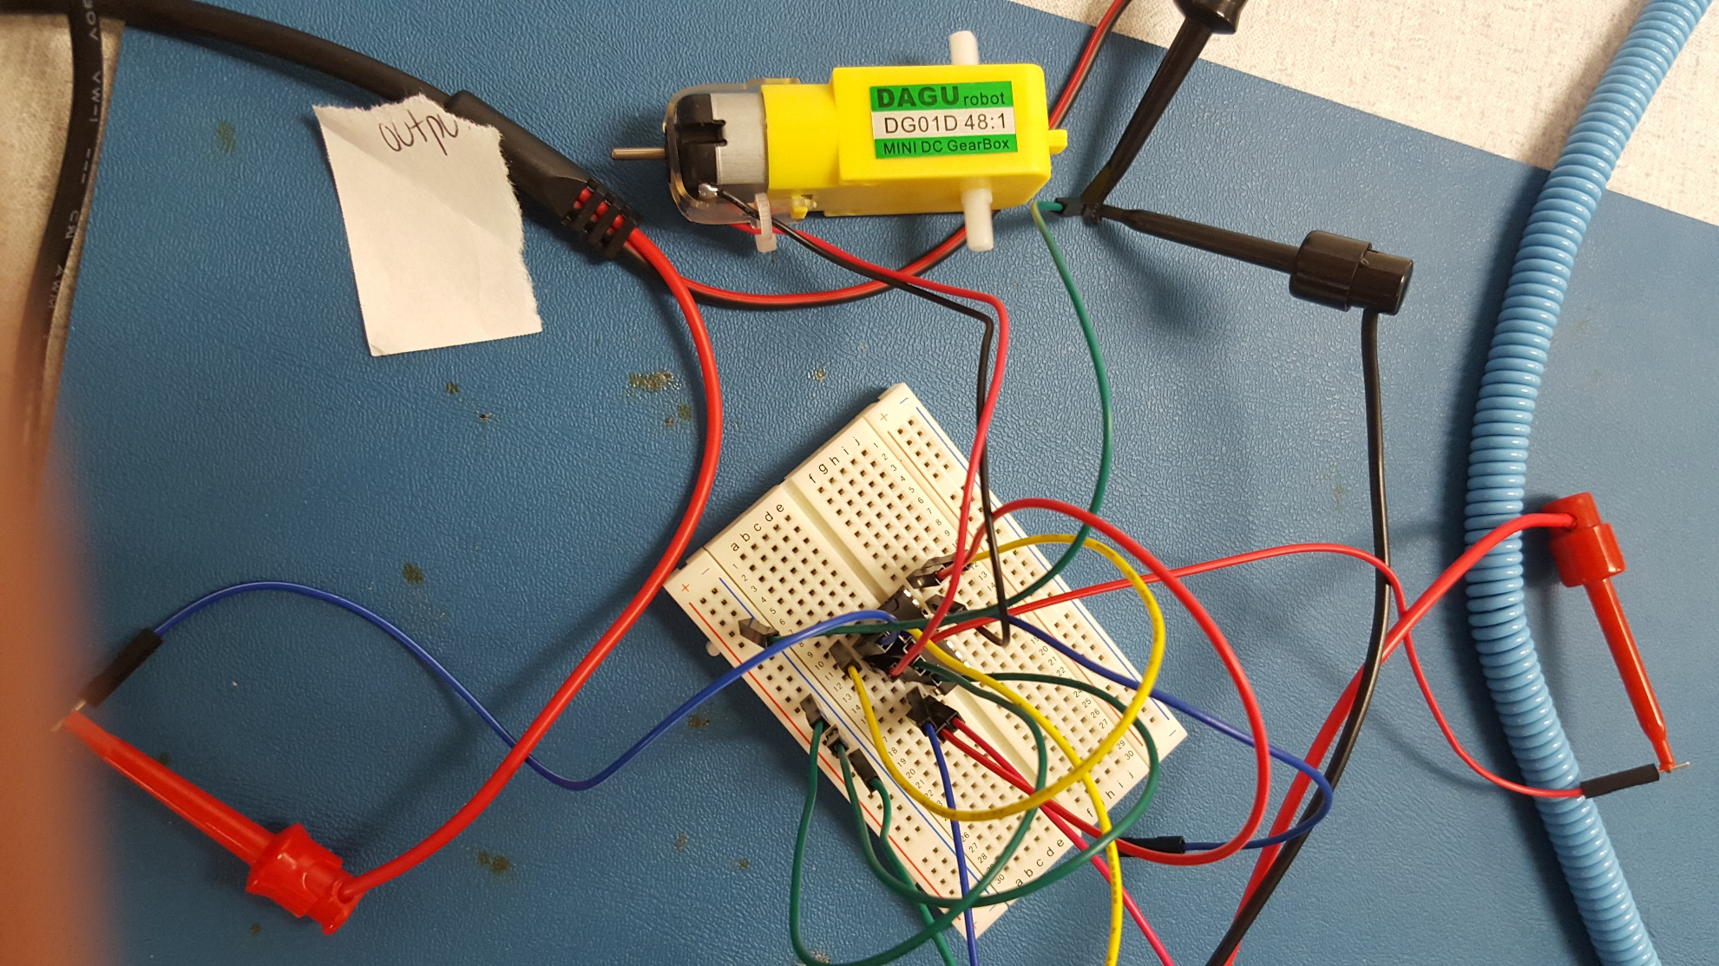

Image 1-4

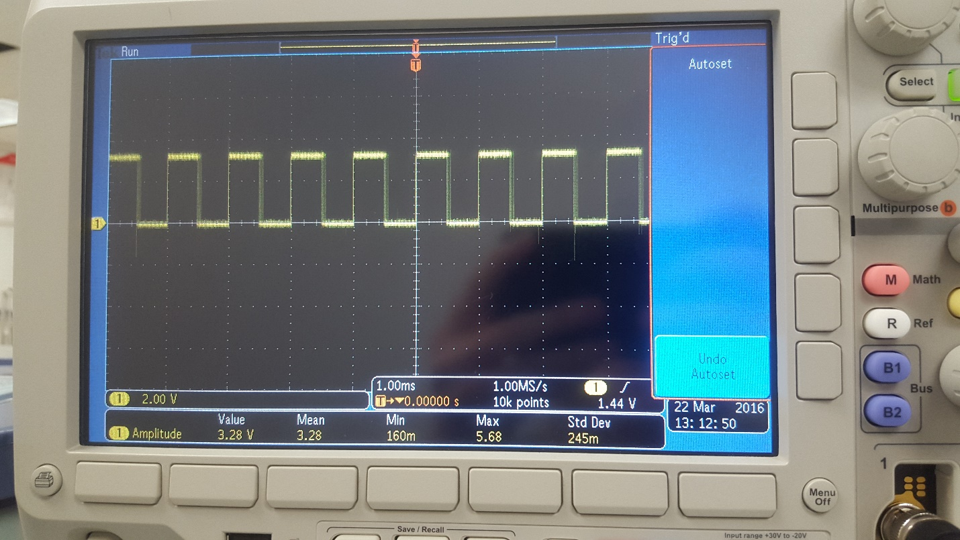

Image 1-5

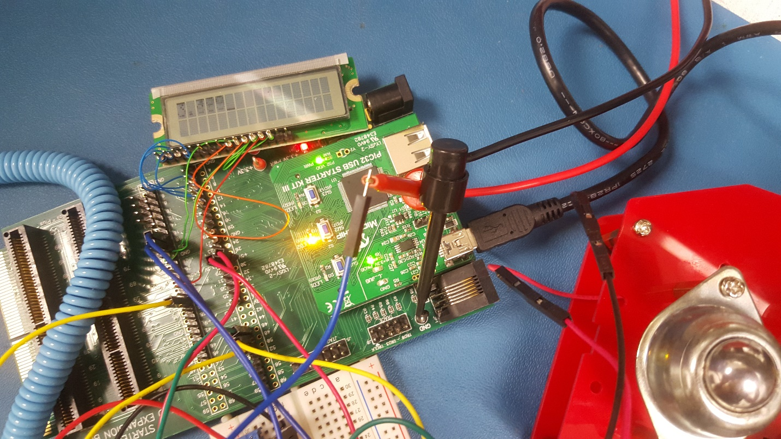

Image 1-6

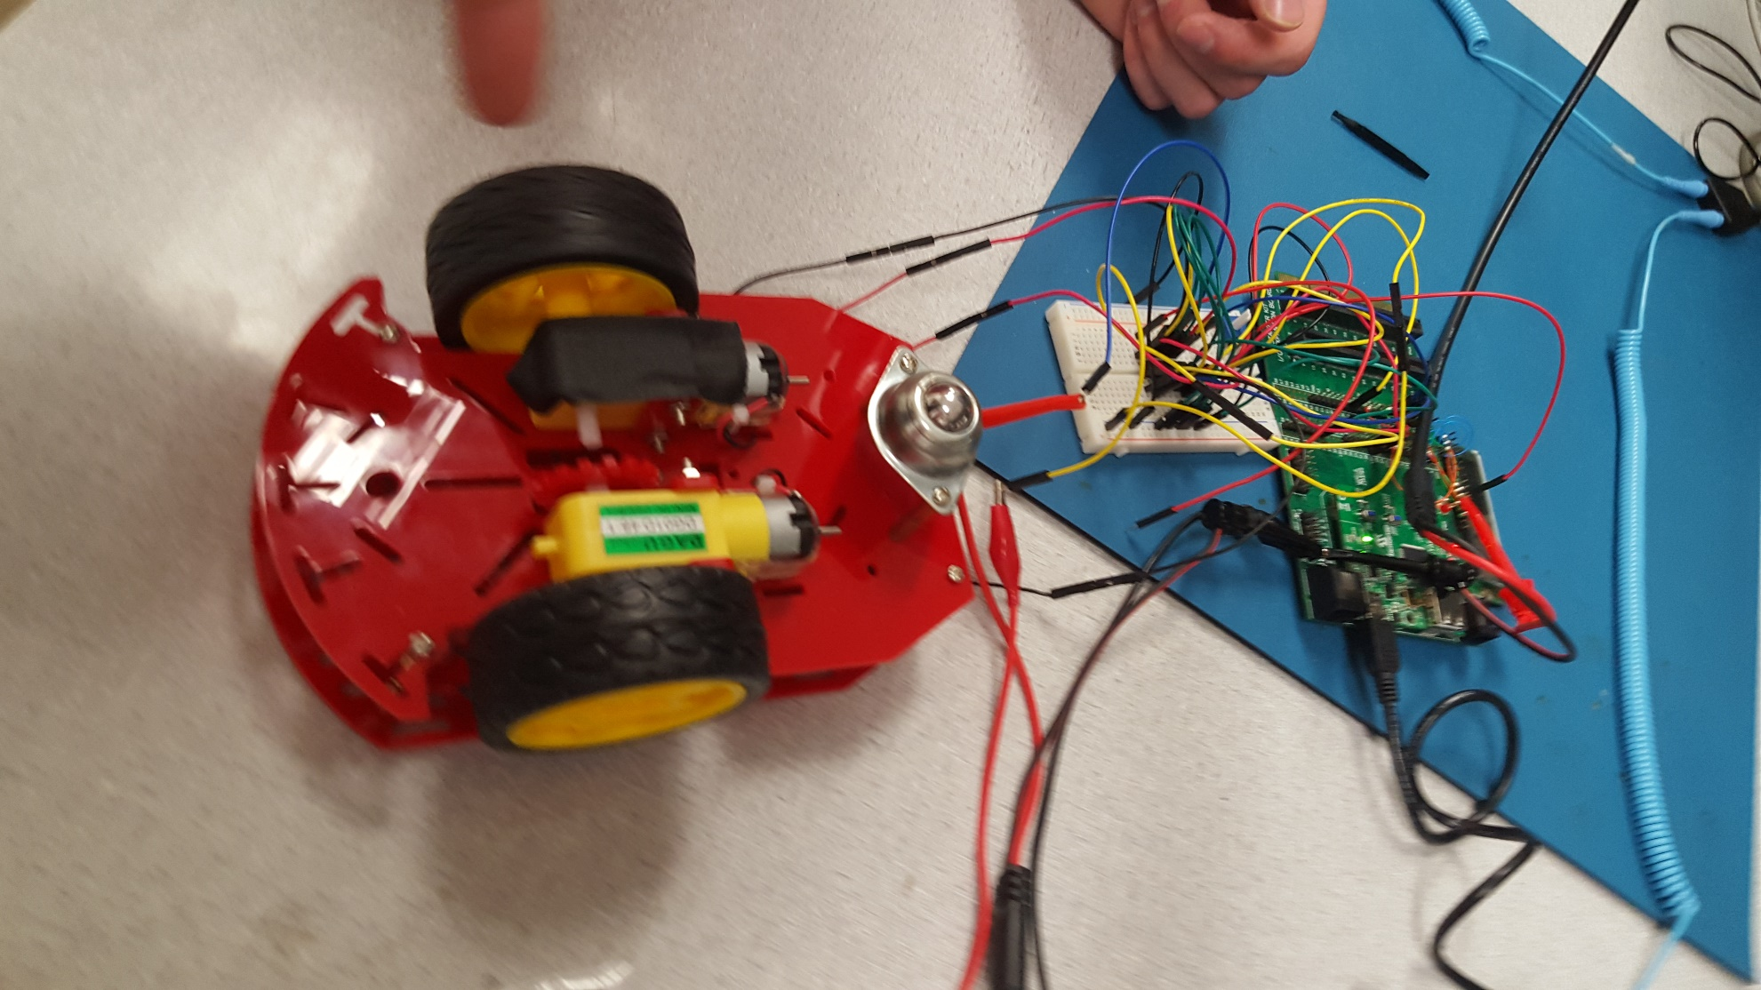

Image 1-7

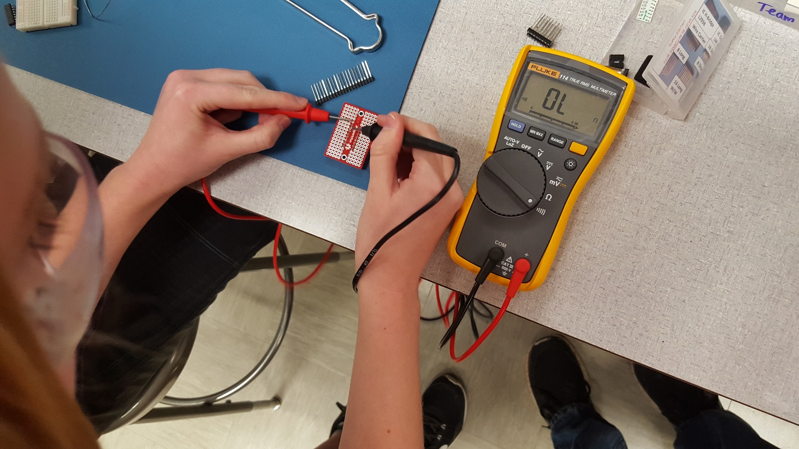

Image 2-1

# Software

For both FSM’s we are constantly polling the ADC buffer for a new voltage in either state. Every time the voltage changes we adjust the display and the OCxRS registers accordingly.

### Part 1 FSM

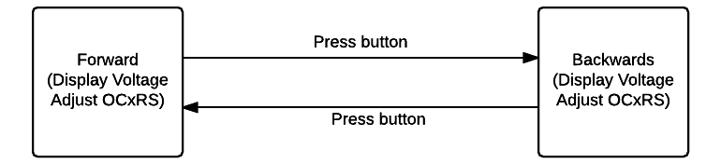

### Part 2 FSM

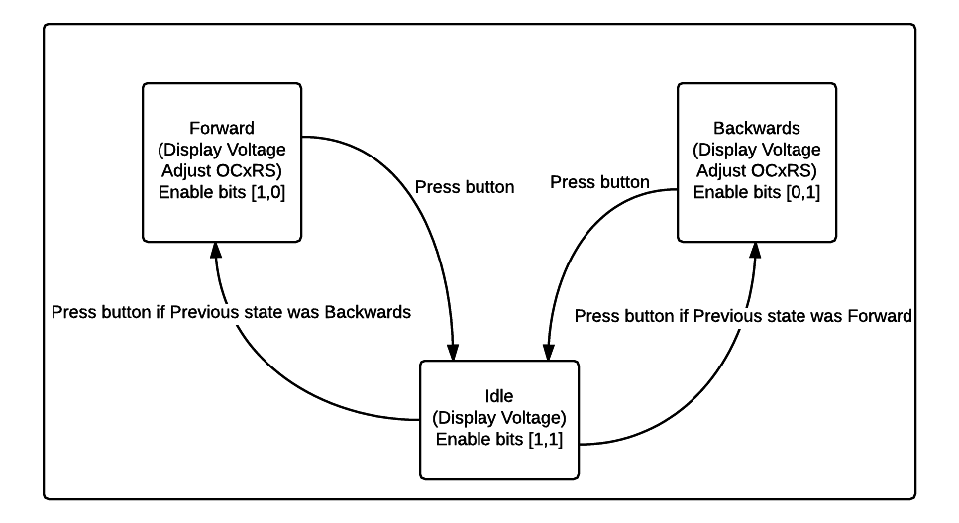

### Commit History

